**LEBANESE AMERICAN UNIVERSITY**

**USAID – HIGHER EDUCATION SCHOLARSHIP PROGRAM**

**HES - Volunteering Program Verification Form**

This form is to be used to document volunteering hours. If a student volunteers for multiple organizations, a separate form must be used for each organization. **This form must be turned in by the 28th of each month, the latest.**

I certify that the scholar Jawad Al housseini completed a total of 10 hours of service at InnovaThrive.

The hours were completed hours as per the below:

Hours # 0 (date) _2/12 – 6/12_ (initials of supervisor) __A.K.___

Hours # 0 (date) _9/12 – 13/12_ (initials of supervisor) __A.K.___

Hours # 0 date) _16/12 – 20/12 (initials of supervisor) __A.K.___

Hours # 10 date) _23/12 - 27/12 (initials of supervisor) __A.K.___

Brief description of the activities the scholar performed or participated in:

My tasks where about doing research about topics like (AI in Early Warning Systems for Natural Disasters,AI in Monitoring and Enhancing Crop Yields in Precision Agriculture).   
In first topic :  
I searched in many sites to explore how AI can optimize crop yields through real-time environmental data analysis.  
in the second topic :   
I searched about leveraging Ai to predict and mitigate the effect of natural disasters.  
In these researches my knowledge about ai is enhanced and i understand more how ai can help us in different fields.

Written feedback about the scholar’s performance:

Jawad displays strong research skills and a deep understanding of AI applications in both agriculture and natural disaster management. His ability to explore diverse fields and enhance his knowledge of AI's potential demonstrates a strong curiosity and problem-solving mindset.

Please rate the overall performance of the scholar at your organization:

|  |  |  |  |
| --- | --- | --- | --- |
|  | Mastery (5) | Proficient (3) | Emerging (1) |
| **Problem solver** | X |  |  |
| **Engaged & Committed** | X |  |  |
| **Open-minded & multicultural** | X |  |  |

Signature

& stamp

__________________________

_

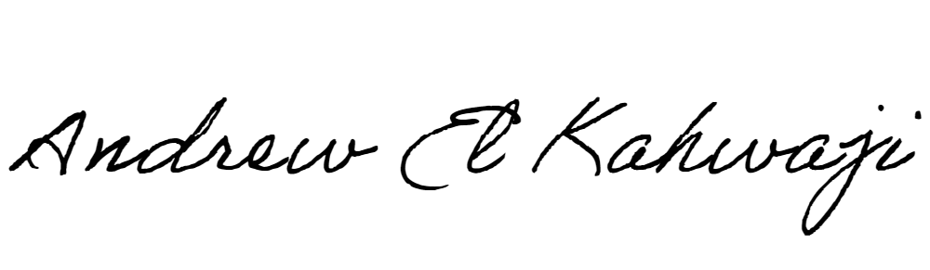

Printed Name _Andrew El Kahwaji_

Date __26/12/2024___

Email __andrew.lifesculptor.coo@gmail.com __

Phone __+961 71 914 378__